|  |
| --- |
| DEK Technologies |
| IMS Overview |
| IP Multimedia Subsystem |
|  |
| **Internship Session 16** |
| **Group Sixteen**  Trần Ngọc Luân  Phạm Thủy Tiên  Nguyễn Vũ Đăng Khánh  Lê Quốc Duy Quang  Nguyễn Tiến Hưng |

|  |
| --- |
| 2018 |

**CONTENT**

1. What is IMS? 3

2. Why should we have IMS? 3

2.1. QoS. 4

2.2. Charging. 4

2.3. Integrated Services. 4

2.4. Independent Application Server and terminals layer. 4

3. IMS Architecture Overview 4

3.1. Application Layer 7

3.1.1. SIP – AS 7

3.1.2. OSA – SCS 7

3.1.3. IM – SSF 8

3.2. Control Layer 8

3.2.1. Database 8

3.2.1.1. HSS – Home Subscriber Server 8

3.2.1.2. SLF – Subscription Locator Function 9

3.2.1.3. Protocol 10

3.2.2. CSCF- Call Session Control Function 10

3.2.2.1. P-CSCF 10

3.2.2.2. I-CSCF 11

3.2.2.3. S-CSCF 12

3.2.3. BGCF – Break Out Gateway Control Function 13

3.3. Access and transport Layer 13

3.3.1. PSTN – Public Switched Telephone Network Gateways 13

3.3.1.1. SGW 13

3.3.1.2. MGCF 13

3.3.1.3. MGW 14

3.3.2. MRF 14

3.3.2.1. MRFC 14

3.3.2.2. MRFP 14

3.3.3. Access Network and UE( User Equipment) 14

**FIGURE**

Figure 1: Overview of the IMS architecture 4

Figure 2: IMS architectural layers overview 6

Figure 3: IMS architectural layers overview – HSS in IMS layer (as by standard) 6

Figure 4: Sample HSS database schema 9

Figure 5 10

Figure 6 11

Figure 7 12

# What is IMS?

**The IP Multimedia Subsystem** or **IP Multimedia Core Network Subsystem (IMS)** is an architectural framework for delivering IP [multimedia](https://en.wikipedia.org/wiki/Multimedia) services. Historically, mobile phones have provided voice call services over a [circuit-switched](https://en.wikipedia.org/wiki/Circuit_switching)-style network, rather than strictly over an IP [packet-switched](https://en.wikipedia.org/wiki/Packet_switching) network. Alternative methods of delivering voice ([VoIP](https://en.wikipedia.org/wiki/VoIP)) or other multimedia services have become available on smartphones, but they have not become standardized across the industry. IMS is an architectural framework to provide such standardization.

IMS, based on SIP and IP, offering multimedia and VoIP services, as well as fixed mobile convergence. IMS has been standardized by the 3rd Generation Partnership Project (3GPP). The 3GPP specification covers all GSM wireless services. IMS is access independent as it supports multiple access types including GSM, WCDMA, CDMA2000, WLAN, WiMAX, LTE, Wireline broadband and future access technologies.

The IMS is the key element in the 3G architecture that makes it possible to provide ubiquitous cellular access to all the services that the Internet provides; an open-systems architecture that supports a range of IP-based services over the PS domain, employing both wireless and fixed access technologies.

IMS uses internet technologies to provide vast services and mobile technology to provide ubiquity, allows user to experience all the services no matter where they are by using IMS infrastructure since it provides telecom services using IP services. As a result as long as a user is connected to IP, that user can enjoy all the services (such as web browsing, e-mail, instant messaging and video conferencing) from any location on any device, no matter where they are even if they are travelling.

# Why should we have IMS?

The idea of the IMS is to offer Internet services everywhere and at any time using cellular technologies. On the other hand, cellular networks already provide a wide range of services, which include some of the most successful Internet services, such as instant messaging. In fact, any cellular user can access the Internet using a data connection and in this way access any services the Internet may provide.

3G networks have a packet-switched domain that provides IP access to the Internet. 3G terminals use native packet-switched technology to perform data communications. This way, data transmissions are much faster and the available bandwidth for Internet access increases dramatically. Users can surf the web, read email, download videos, and do virtually everything they can do over any other Internet connection, such as ISDN (Integrated Services Digital Network) or DSL (Digital Subscriber Line). This means that any given user can install a VoIP client in their 3G terminal and establish VoIP calls over the packet-switched domain. Such a user can take advantage of all the services that service providers on the Internet offer, such as voicemail or conferencing services.

So why do we need the IMS, when all the power of the Internet is already available for 3G users through the packet-switched domain?

Those reasons are below:

* QoS (Quality of Service).
* Charging.
* Integration of different services.
* Independent Application Server and terminals layer not in the IMS.

## QoS.

## Charging.

## Integrated Services.

## Independent Application Server and terminals layer.

# IMS Architecture Overview

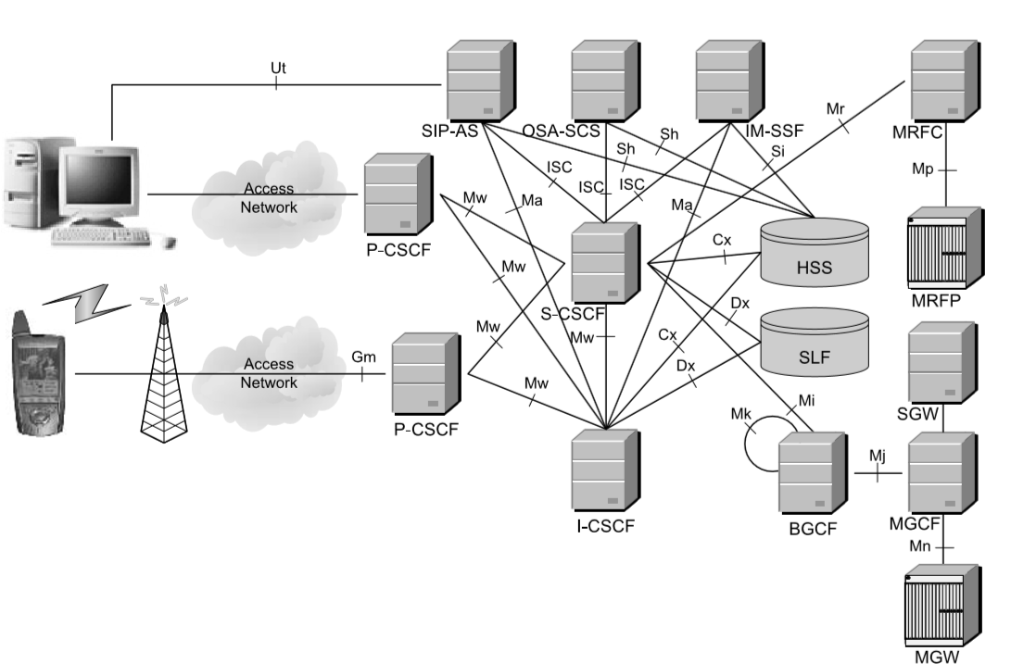

Figure 1: Overview of the IMS architecture

Figure 1 provides an overview of the IMS architecture as standardized by 3GPP. The ﬁgure shows most of the signaling interfaces in the IMS, typically referred to by a two or three-letter code. This does not include all the interfaces deﬁned in the IMS, but only the most relevant ones. The reader can refer to 3GPP TS 23.002 [17] to ﬁnd a complete list of all the interfaces.

On the left side of Figure 1 we can see the IMS mobile terminal, typically referred to as the User Equipment (UE) such as [mobile phones](https://en.wikipedia.org/wiki/Mobile_phone), [personal digital assistants](https://en.wikipedia.org/wiki/Personal_digital_assistant) (PDAs) and computers. The IMS terminal attaches to a packet network, such as the GPRS network, through a radio link. The IMS also supports other types of access like WLAN or ADSL.

The remainder of Figure 1 shows the nodes included in the so-called IP Multimedia  
Core Network Subsystem. These nodes are:

* One or more user databases, called HSSs (Home Subscriber Servers) and SLFs (Subscriber Location Functions).
* One or more SIP servers, collectively known as CSCFs (Call/Session Control Functions);
* One or more ASes (Application Servers).
* One or more MRFs (Media Resource Functions), each one further divided into MRFCs (Media Resource Function Controllers) and MRFPs (Media Resource Function Processors).
* One or more BGCFs (Breakout Gateway Control Functions).
* One or more PSTN gateways, each one decomposed in to an SGW (Signaling Gateway), an MGCF (Media Gateway Controller Function), and an MGW (Media Gateway).

The resulting IMS architecture defines elements and functions on three layers, shown in figure 2 and figure 3:

* Application Layer
* Control /IMS Layer
* Access and Transport Layer

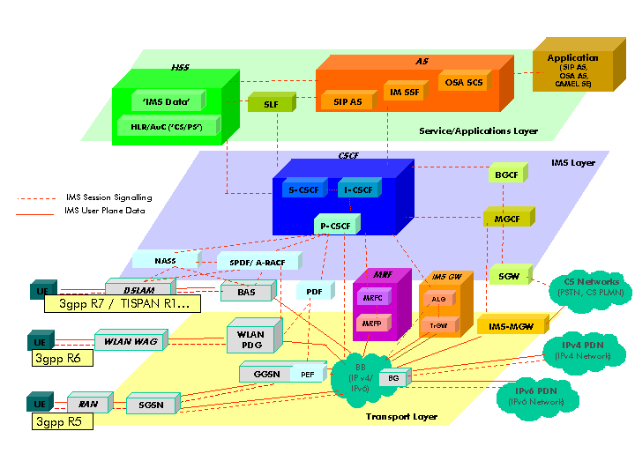

Figure 2: IMS architectural layers overview

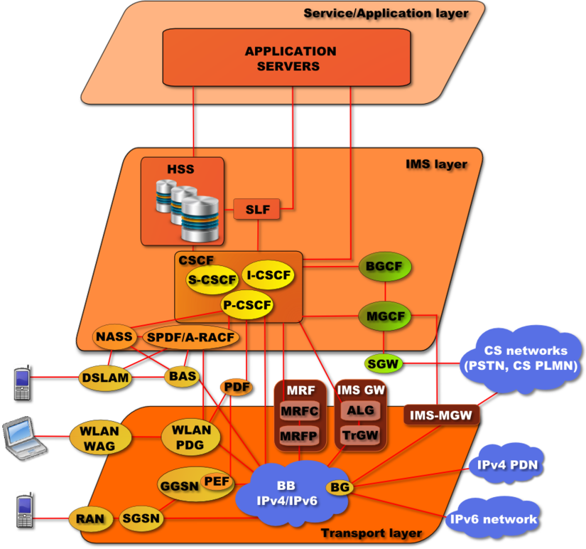

Figure 3: IMS architectural layers overview – HSS in IMS layer (as by standard)

## Application Layer

The Application Server (AS) is a SIP entity that hosts and executes services. Depending on the actual service the AS can operate in:

* SIP proxy mode.
* SIP UA (User Agent) mode.
* SIP B2BUA (Back-to-Back User Agent) mode.

Application Servers interfaces with:

* HSS using DIAMETER .(home network)
* S-CSCF and I-CSCF using SIP.
* AS  allows third-party providers easy integration and deployment of their value-added services to the IMS infrastructure. It can provide IMS terminals with an interface that is used for conﬁguration purposes. This examples of services are:
* – Caller ID related services (CLIP, CLIR, ...)
* – Call waiting, Call hold, Call pick up
* – Call forwarding, Call transfer
* – Call blocking services, Malicious Caller Identification
* – Lawful interception – Announcements, Digit collection
* – Conference call services – Location based services
* – SMS, MMS
* – Presence information, instant messaging
* – Voice Call Continuity Function (VCC Server) or Fixed Mobile Convergence

There are three types of Application Server:

* SIP – AS
* OSA – SCS
* IM – SSF

All three types of AS behave as SIP ASes toward the IMS network (i.e., they act as a SIP proxy server, a SIP User Agent, a SIP redirect server, or a SIP Back-to-Back User Agent).

The IM-SSF AS and the OSA-SCS AS have other roles when interfacing CAMEL or OSA, respectively.

### SIP – AS

This is the native AS that hosts and executes IP Multimedia Services based on SIP. It is expected that new IMS-specific services will probably be developed in SIP ASes.

### OSA – SCS

This AS provides an interface to the OSA framework AS. It inherits all the OSA capabilities, especially the capability to access the IMS securely from external networks.

This node acts as an AS on one side (interfacing the S-CSCF with SIP) and as an interface between the OSA AS and the OSA Application Programming Interface (API, described in 3GPP TS 29.198[18]).

### IM – SSF

This specialized AS allows us to reuse CAMEL (Customized Applications for Mobile network Enhanced Logic) services that were developed for GSM in the IMS.

The IM-SSF allows a gsmSCF (GSM Service Control Function) to control an IMS session. The IM-SSF acts as an AS on one side (interfacing the S-CSCF with SIP). On the other side, it acts as an SSF (Service Switching Function), interfacing the gsmSCF with a protocol based on CAP (CAMEL Application Part, defined in 3GPP TS 29.278 ).

## Control Layer

### Database

#### HSS – Home Subscriber Server

HSS is the master database support IP Multimedia Subsystem (IMS). HSS contains information about the subscriptions related to the support of the network, that information necessary for establishing sessions between users and providing services to them. The user information includes user profile such as location, registration, the allotted S-CSCF address, etc. all the information is stored in a standard format and HSS decides user sessions based on these items or user information.

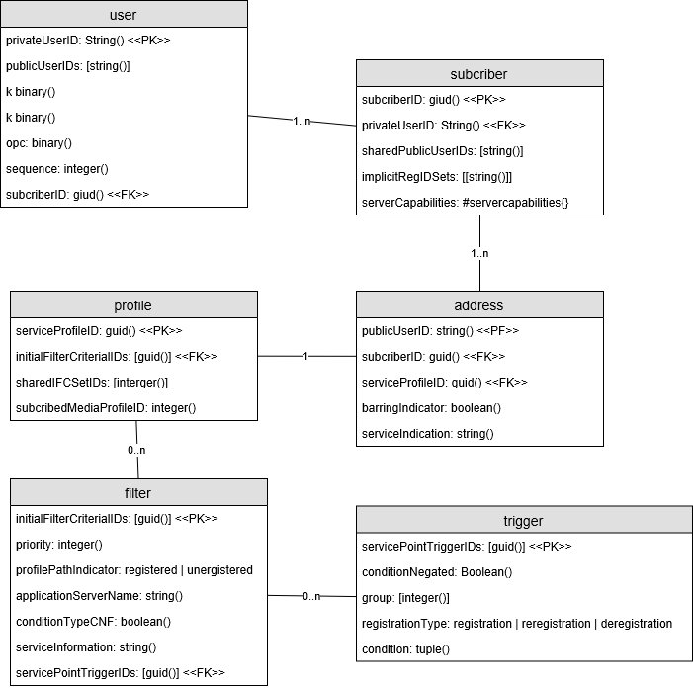

Figure 4: Sample HSS database schema

The diagram in Figure. 4 shows a sample HSS database schema. HSS maintains the data related to subscribers of IMS services. User identifier uses the identity of a private person in Network Access Identifier (NAI) in the form of “user@area”. The communication with user concerns, the public identity in the form of either SUP URI (Session Initiation Protocol – Uniform Resource Identifier) or TEL URL (Uniform Resource Locators for Telephone Calls).

Temporary subscriber data are called registrations, its describes the registration status of Public User Identities and contain the name (or address) of S-CSCF, where the registration is ongoing. A user profile maybe kept without any registrations within S-CSCF. Unregistered Public User Identities do not have record in the table

The HSS supports many interfaces – the most important are Cx and Sh. Cx is used to communicate with the ICSCF (Interrogating - CSCF) and S-CSCF (Serving CSCF). Sh is connected with application servers. Both interfaces are based on DIAMETER protocol.

#### SLF – Subscription Locator Function

A network may contain more than one HSS in order to handle a large number of subscribers, the SLF is used to locate the HSS where the user information is stored. The SLF is a simple database which maps the user’s address with an HSS

#### Protocol

Both HSS and SLF use Diameter protocol defined in [RFC 3588](https://tools.ietf.org/html/rfc3588). The Diameter protocol which are specific applications developed for IMS in the matter of authentication, authorization and accounting for a particular user

### CSCF- Call Session Control Function

The CSCF (Call/Session Control Function), which is a SIP server, is an essential node in the IMS. The CSCF processes SIP signaling in the IMS. There are 3 types of CSCF, depending on the functionality they provide. All of them collectively known as CSCFs, but an individual CSCF belongs to one of the following three categories:

* P-CSCF (Proxy-CSCF)
* I-CSCF (Interrogating-CSCF)
* S-CSCF(Serving-CSCF)

#### P-CSCF

The P-CSCF is the first point of contact (in the signaling plane) between the IMS terminal and the IMS network. All the requests initiated by the IMS terminal or destined for the IMS terminal traverse the P-CSCF. The P-CSCF forwards SIP requests and reponses in the appropriate direction.

The P-CSCF is allocated to the IMS terminal during IMS registration and does not change for the duration of the registration (i.e., the IMS terminal communicates with a single P-CSCF during the registration).

The P-CSCF includes several functions, some of which are related to **security**. First, it establishes a number of IPsec security associations toward the IMS terminal. These IPsec security associations offer integrity protection (i.e., the ability to detect whether the contents of the message have changed since its creation).

Once the P-CSCF authenticates the user, the P-CSCF asserts the identity of the user to the rest of the nodes in the network. This way, other nodes do not need to further authenticate the user, because they trust the P-CSCF. The rest of the nodes in the network use this identity (asserted by the P-CSCF) for a number of purposes, such as providing personalized services and generating account records. In addition, the P-CSCF verifies the correctness of SIP requests sent by the IMS terminal. This verification keeps IMS terminals from creating SIP requests that are not built according to SIP rules.

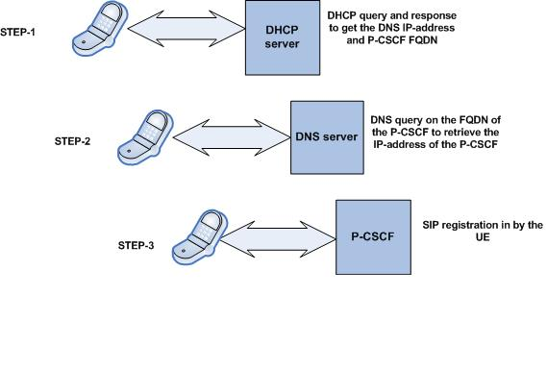

Figure 5

The P-CSCF also includes a compressor and a decompressor of SIP messages. SIP messages can be large, given that SIP is a text-based protocol. While a SIP message can be transmitted over a broadband connection in a fairly short time, transmitting large SIP messages over a narrowband channel, such as some radio links, may take a few seconds. The mechanism used to reduce the time to transmit a SIP message is to compress the message, send it over the air interface, and decompress it at the other end.

The P-CSCF may include a PDF. The PDF may be integrated with the P-CSCF or be implemented as a stand-alone unit. The PDF authorizes media plane resources and manages Quality of Service over the media plane.

An IMS network usually includes a number of P-CSCFs for the sake of scalability and redundancy. Each P-CSCF serves a number of IMS terminals, depending on the capacity of the node.

Location: The P-CSCF may be located either in the visited network or in the home network.

#### I-CSCF

The I-CSCF is a SIP proxy located at the edge of an administrative domain. The address of the I-CSCF is listed in the DNS (Domain Name System) records of the domain. When a SIP server follows SIP procedures to find the next SIP hop for a particular message, the SIP server obtains the address of an I-CSCF of the destination domain.

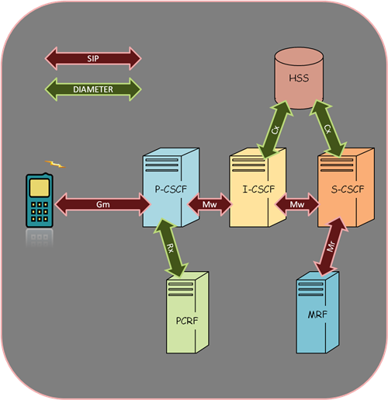

Figure 6

Besides the SIP proxy server functionality, the I-CSCF has an interface to the SLF and the HSS. This interface is based on the Diameter protocol. The I-CSCF retrieves user location information and routes the SIP request to the appropriate destination (typically an S-CSCF).

The I-CSCF also implements an interface to Application Servers, in order to route requests that are addressed to services rather than regular users. In addition, the I-CSCF may optionally encrypt the parts of the SIP messages that contain sensitive information about the domain, such as the number of servers in the domain, their DNS names, or their capacity.

Location: The I-CSCF is usually located in the home network, although in some special cases, such as an I-CSCF(THIG), it may be located in a visited network as well.

#### S-CSCF

The S-CSCF is the central node of the signaling plane. The S-CSCF is essentially a SIP server, but it performs session control as well. In addition to SIP server functionality the S-CSCF also acts as a SIP registrar. This means that it maintains a binding between the user location (e.g., the IP address of the terminal the user is logged onto) and the user’s SIP address of record (also known as a Public User Identity).

Like the I-CSCF, the S-CSCF also implements a Diameter interface to the HSS. The main reasons to interface the HSS are as follows.

• To download the authentication vectors of the user who is trying to access the IMS from the HSS. The S-CSCF uses these vectors to authenticate the user.

• To download the user profile from the HSS. The user profile includes the service profile, which is a set of triggers that may cause a SIP message to be routed through one or more ASes.

• To inform the HSS that this is the S-CSCF allocated to the user for the duration of the registration.

All the SIP signaling the IMS terminals sends, and all the SIP signaling the IMS terminal receives, traverses the allocated S-CSCF.

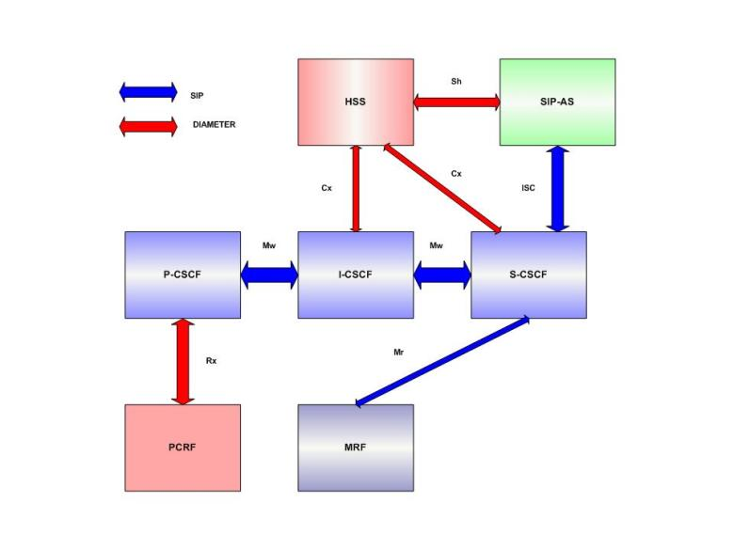

Figure 7

The S-CSCF inspects every SIP message and determines whether the SIP signaling should visit one or more ASes en route toward the final destination. Those ASes would potentially provide a service to the user. One of the main functions of the S-CSCF is to provide SIP routing services. If the user dials a telephone number instead of a SIP URI (Uniform Resource Identifier), the S-CSCF provides translation services, typically based on DNS E.164 Number Translation.The S-CSCF also enforces the policy of the network operator. For example, a user may not be authorized to establish certain types of session. The S-CSCF keeps users from performing unauthorized operations. A network usually includes a number of S-CSCFs for the sake of scalability and redundancy. Each S-CSCF serves a number of IMS terminals, depending on the capacity of the node.

Location: The S-CSCF is always located in the home network.

### BGCF – Break Out Gateway Control Function

Breakout Gateway Control Function (BGCF) is an essentially SIP server provides connectivity to the Circuit Switch domain. We need BGCF when routing or establishing session based on telephone number as user address. The BGCF is used exclusively for session initialed by an IMS user who need to communicate with a user in the PSTN domain. The main functionality of the BGCF:

* Select appropriate network where interworking with the circuit-switched domain to occur.
* Select an appropriate PSTN/CS gateway if interworking is to occur in the network  
  where the BGCF is located
* Generate CDTs to forward to the charging collection node.

The BGCF locates between S-CSCF and MGCF.

## Access and transport Layer

### PSTN – Public Switched Telephone Network Gateways

The PSTN gateway provides an interfaces toward a circuit-switched network, allowing IMS terminals to make and receive calls to and from the PSTN.

#### SGW

SGW provides the signaling interface with the circuit switched domain. Its main function is to perform lower level protocol conversion. It converts MTP (Message Transfer Part) defined in ITU-T Recommendation Q.701 into SCTP (Stream Control Transmission Protocol) defined in RFC 2960 over IP. So the signaling format ISUP or BICC over MTP is transformed into ISUP or BICC over SCTP/IP.

#### MGCF

MGCF interfaces with the BGCF and receives the SIP signaling. Its function is to convert the SIP signaling to either ISUP (Signaling System 7) defined in ITU-T Recommendation Q.761 over IP or BICC (Bearer Independent Call Control) defined in ITU-T Recommendation Q.1901 over IP. The converted signaling is forwarded to the Signaling Gateway (SGW). The MGCF also controls the resources in the Media Gateway (MGW). The MGCF and the MGW communicate with the help of the H.248 protocol, specified in the ITU-T Recommendation H.248.

#### MGW

MGW connects the media plane of the PSTN or any other CS environment with the media plane of IMS. The MGW transcodes the IMS data transported over RTP (Real Time Protocol) defined in RFC 3550 [93] into PCM (Pulse Code Modulation) used in the PSTN environment. Also the MGW performs transcoding in situations where the IMS terminal does not support the codec being used by the CS side.

### MRF

The Media Resource Function (MRF) handles all the media transportation and processing requirements. It is divided into two functional components, the Media Resource Function Controller (MRFC) and the Media Resource Function Processor (MRFC).

#### MRFC

The MRFC interfaces with the S-CSCF over the Mr interface and uses SIP for signaling purposes. The tasks performed by the MRFC are as below :

• It controls the media stream resources in the MRFP.

• The MRFC interprets the information forwarded by the S-CSCF and the Application Servers and modifies the operation of the MRFP according to the directions.

• The MRFC generates CDRs like the other nodes in IMS to be forwarded to the charging collecting node.

#### MRFP

The MRFP is controlled by the MRFC though the Mp interface, also called a reference point. The Mp reference point does not have a specific protocol specified for it yet and has an open architecture to allow extension work to be carried out. It completely supports the H.248 Standard . The tasks performed by the MRFP are given below :

• The MRFP controls the bearer plane on the Mb reference point.

• It provides the functionality of mixing various incoming media streams in case of a conference call.

• It acts as a source of media streams or plays streams as for multimedia announcements.

• The MRFC performs all other media processing functions such as transcoding, media analysis etc.

• It also provides floor control or manages access rights in a conference environment.

### Access Network and UE( User Equipment)